Company Profile
2016
ITOG
Delivering Excelleance in Engineering

Home:

WELCOME TO

ITOG Engineering
ITOG ENGINEERING is one of leading and fast growing Engineering and Fabrication Company, providing Design, Engineering & Fabrication solutions to various industries across the country with fully-equipped facility extending over 15,000 Sq. Ft with cover shop area of 3,000 Sq. Ft at very prime industrial location at Panoli GIDC in Bharuch District of Gujarat.

The company is established by founders/Engineers with an experienced background in designing, Engineering and Procurement, fabrication, Manufacturing, operations & management.

ITOG undertake the design, fabrication, manufacture and supply of all kind of Steel Structures, Pipe Spool, Pressure Vessel, Storage Tanks, Jigs & Fixtures, Process equipment, Material Handling Equipment and spare part development.

ABOUT US

ITOG ENGINEERING is one of leading and fast growing Steel Fabrication Units, providing Design, Engineering & Fabrication solutions to various industries across the country with fully-equipped facility extending over 15,000 Sq. Ft with cover shop area of 3,000 Sq. Ft at very prime industrial location at Panoli GIDC in Bharuch District of Gujarat.

ITOG's core competences lies in the Light & Medium Steel Fabrication and Supply including Machining and assembly of Steel Structure, Pipe Spool, Material Handling equipment and Process equipment for various domestic as well overseas Project in Close association with various OEM and Process Plants.

The merit of our company is to offer a comprehensive service (Design, Engineering, Fabrication, Supply and maintenance Services) in the field of Mechanical and Structural Engineering. We can ensure timely delivery, end-to-end quality management and budget control.

Our team of qualified, experienced engineers and technicians can create and build to client specifications, whatever the challenge. Our clients are ensured the highest levels of product quality and workmanship including on-time completion.

Team of ITOG Engineering is having rich experience in field of Fabrication of Pressure Vessels, Column, Reactor and Heavy Material Handling equipment during their tenure with major Fabrication & Manufacturing Companies.

We specialize in:
- Carbon Steel/ Mild Steel Fabrication
- Stainless Steel Fabrication

 | Our vision is to Supply High Quality Engineering Products and Services to our Customers.  Our manpower resources will be constantly trained and equipped with best technology and machineries in order to achieve the goal of Customer satisfaction, Quality and sustainable Growth.
 | Our mission is to be known and trusted by our customers to deliver best Product and Services.  We are committed to exceed the expectations of our valuable Customers.
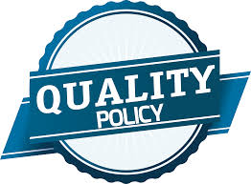 | Complying with product and quality system requirements.  Supplying consistent quality products to our valued customers.

Industries we serve

- Thermal Power Plants
- Oil & Gas Sector
- Renewable energy Sector-Solar Power Plant
- Chemical & Fertilizers
- Petro-Retail Industries
- Heavy Engineering Company
- Manufacturing Industry
- Petro-Retail Industries
- Steel Industry

Business Activities
- Fabrication:
- Stationary Equipments i.e. Pressure vessels, Storage Tanks, Reactors, Receivers, Autoclaves, Heat Exchangers, Distillation Columns, Pig Launcher/Receiver.
- Rotary Equipments: Pumps Casing, Gear Box Casing
- Pipe Spools and piping fabrication as per client`s drawings.
- Skid Packages with complete process/mechanical design in various materials and applications
- Technological Structure Fabrication, Pre Engineered Building Structure
- Jigs & Fixtures, Material Handling Trolley, Platforms, Foundation Bolts and other miscellaneous Fabrication job as per client drawings.
- Special Purpose Equipments like Reactors, Ball Mills, Ball Digesters, Acid thickener and all type of fabrication.
- Specialized Fabrication item as per client requirement like Motor base frame, pump base frame, lube oil tanks etc.
All pressurized products are Designed and Constructed as per ASME Sec VIII Div I, ASME B 31.4/31.8/31.3,IS 2825, TEMA, API & ASTM etc. codes.
We can fabricate in Carbon Steel, Stainless steel, Nickel alloy.

- Services:
  - DESIGN & ENGINEERING

Process engineering services
Mechanical design
Drafting/3D modeling
Material engineering

  - REPAIR AND MAINTENANCE SERVICES (MECHANICAL, PIPING, ELECTRICAL, CIVIL)

  - VESSEL/TANK FABRICATION & REPAIR

Conversions, Upgrades, Refits, In-Situ-Repairs

  - MACHINE REPAIRING

Industrial Motor Winding, Plumbing, Electrical, Masonry Work, Boring, Facing, Press Work, Hydraulic Equipment Repairing, Sheet Cutting, Shearing, Bending, Rolling

  - MACHINE JOBS

Shafts, Cams, Tank and Tankers, manderals, Housing, Conveyor Drum, Die Making, Nozzles, Threading, Milling

  - ANNUAL RATE CONTRACTS:

We can undertake Annual rate contract works for Maintenance including Mechanical maintenance/construction work for equipment, machinery & piping and electrical installation and maintenance.

- construction DIVISION:
Our Construction Davison is manufacturers & suppliers of world class quality cement concrete products. We are having brick paving manufacturing facility in vicinity of our steel Fabrication and manufacturing workshop in Panoli GIDC.
Our Products are:

- Reflective Rubber Mold Paver Block
- Heavy Duty Paver Block
- Curb Stone
- Ashtkon Paver Block
- Interlocking Paver
- Designer Pavers
- Grey Pavers
- Hexagonal Pavers
- Zig Zag Paver Block

Our Civil Construction Division take undertake any job related to Building Construction, Paver block Fixing, Curb Stone Fixing and Painting work

Manufacturing facility

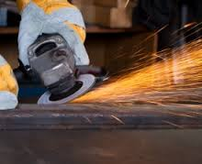
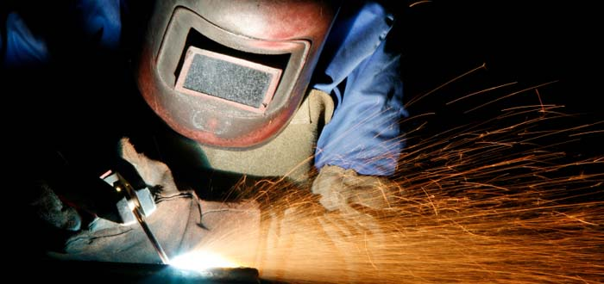

Total Area of the Premises : 15,000 Sq. Feet
Cover Shop Area : 3,000 Sq. Feet
Office Area : 400 Sq. Feet

Lifting Capacity : 7.5 Ton Lifting Capacity (Gantry Crane)
Welding Machine : SMAW - 2 Nos.
GTAW - 2 nos.
Low Hydrogen SMAW welding consumable Backing Oven
Radial Drill Machine : Φ3 to Φ40 mm
Turning Lathe : Up to 14” OD and 4.5 Feet Bed Length.
Grinding Machine : Manual Grinding Machine.
Gas Cutting : Gas cutting facility up to 80 mm.
Testing Faculties : Hydrostatic test, Dry Penetrant Test (PT)
Radiography Test (UT), Ultrasonic Test (UT),
Magnetic Particle Inspection Test (MT)

- Product Testing

ITOG provides a variety of different types of testing that include, but are not limited to, hydro-testing, leak testing, liquid penetrant testing, ultrasonic testing, visual examinations, and radiographic testing. Final inspection and testing is performed on our pipe spools and skids before being shipped to the customer. This helps to ensure that we consistently supply the highest quality of products to our customers.

- Project Management

The ITOG team relies on thorough project management from engineering throughout the delivery to ensure the highest level of success on each and every project that we handle.

- Product photographs

PIPE SPOOLS

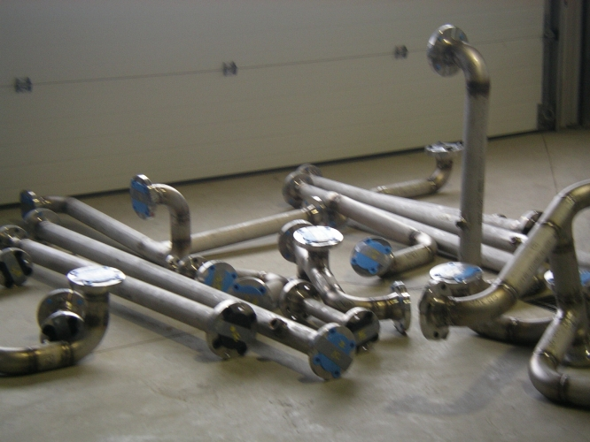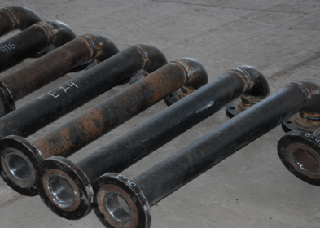

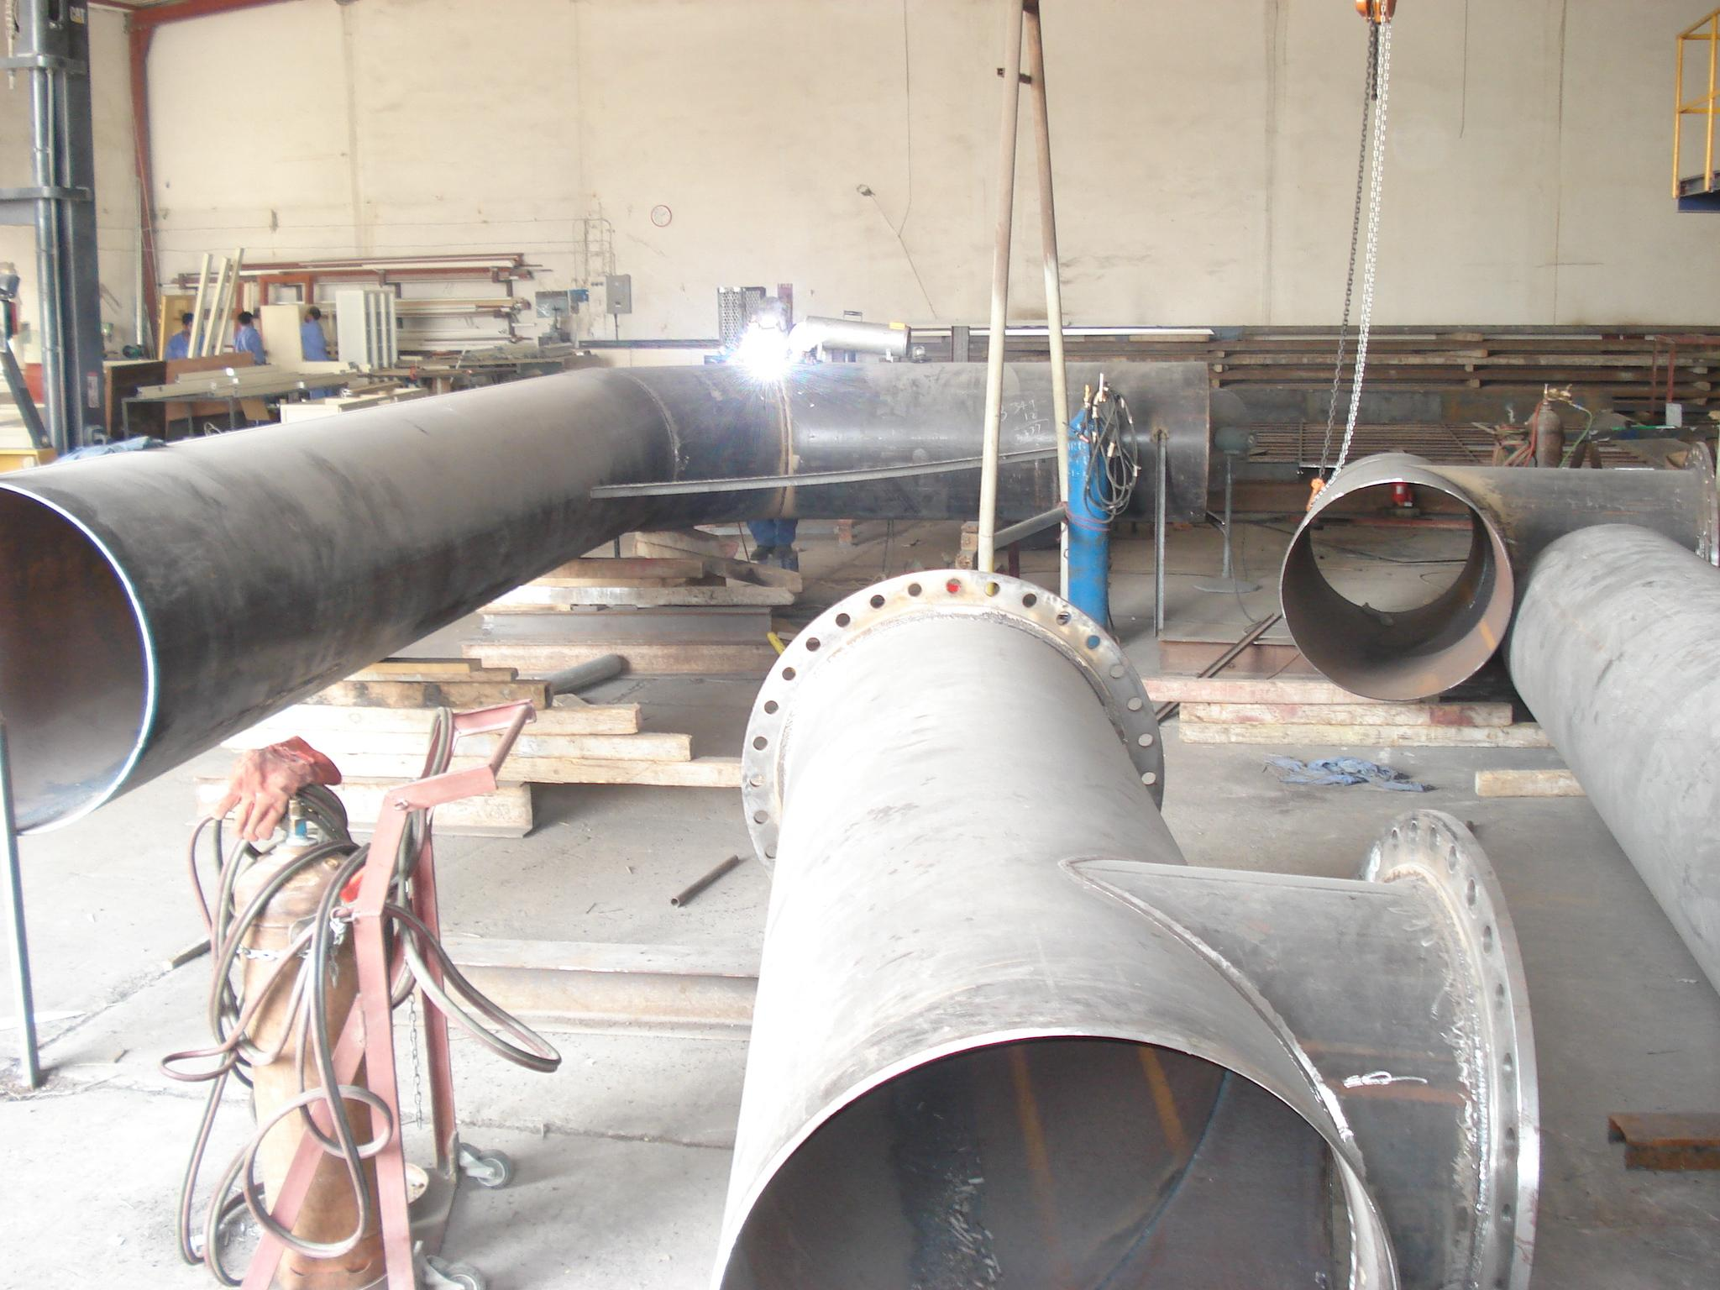

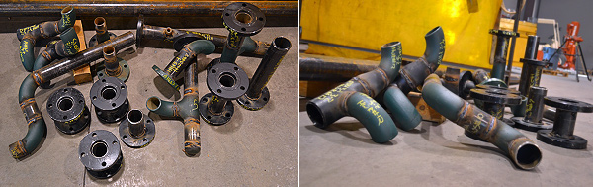

FABRICATION

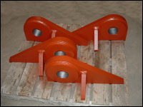  Heavy Plate Fabrication Lug | 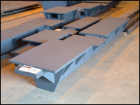  Motor Base
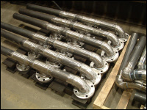  Pipe Weldment with heavy flanges | 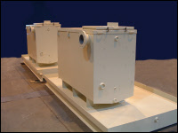  Hydraulic Lube Tanks
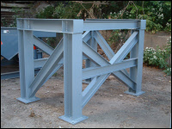  Customized Structure | 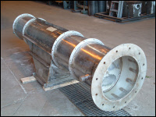  Small Chimney/Stack

Lubricant Display Units Supplied To
Reliance Industries Limited
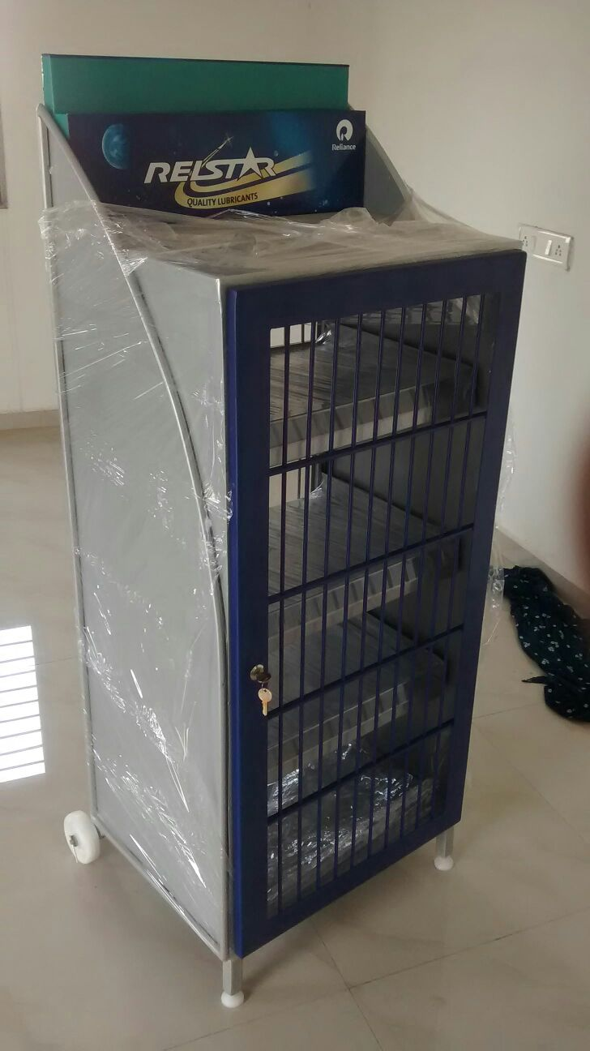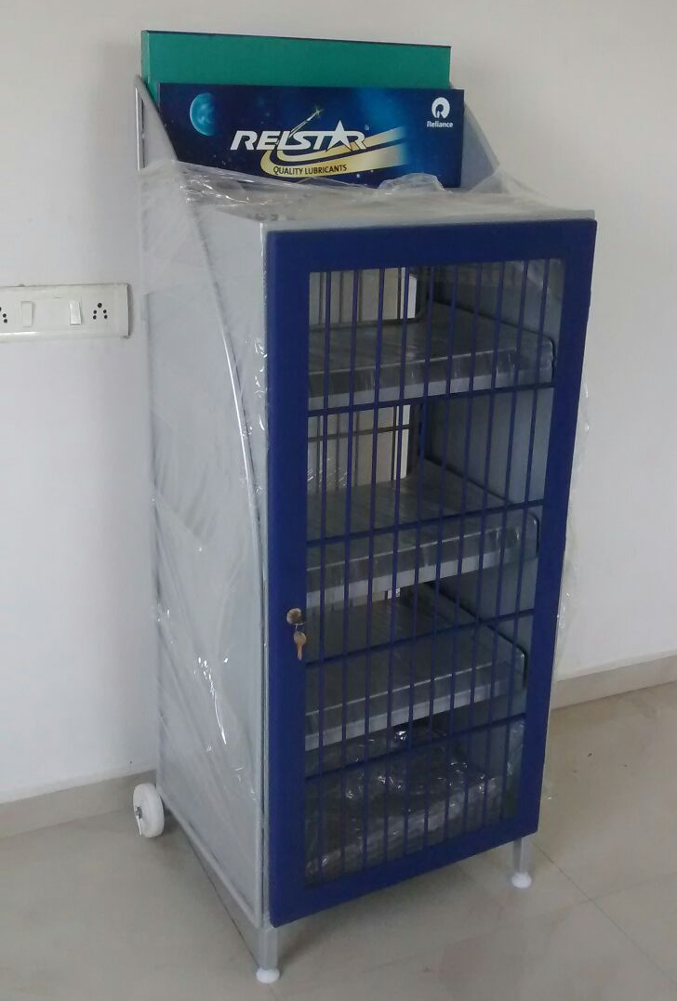

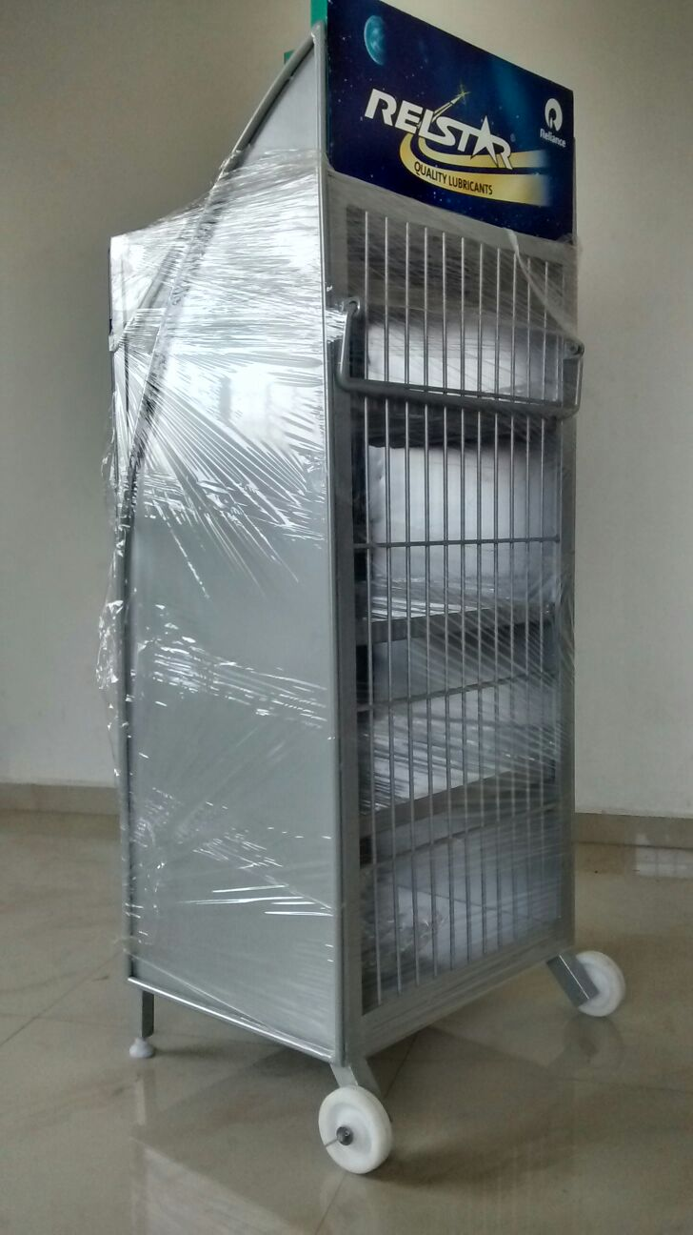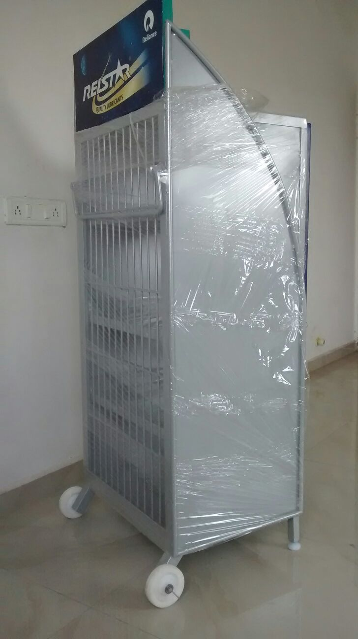

MATERIAL HANDLING PRODUCTS

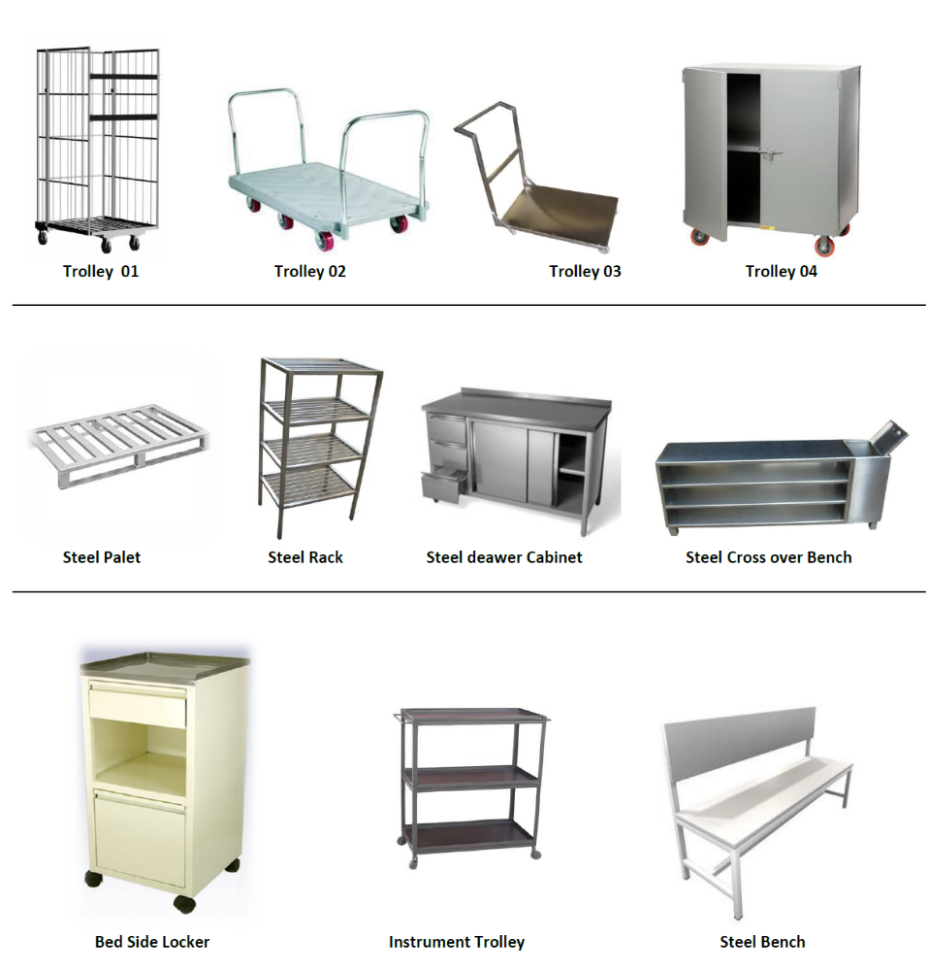

- General INFORMATION
- Company Name : M/s. ITOG Engineering
- Registered Office : Plot No. 2319, Phase-3,
G.I.D.C., Panoli, Ta: Ankleshwar,
Bharuch, Gujarat-394116, India
- Factory Address : Same as above
- Business Activities : Design, Engineering and Fabrication
Trading of all types of spare part
- Banker Name : HDFC Bank, GIDC, Ankleshwar
Account No.: 50200010905422
NEFT / RTGS IFSC Code: HDFC0002677
- GST/VAT No : 24211300822 dated 04.07.2015
- CST/TIN No : 24711300822 dated 04.07.2015
- Service Tax Reg No. : AAFFI1897LSD001 dated 19.06.2015
- PAN : AAFFI1897L

